**Customer:**

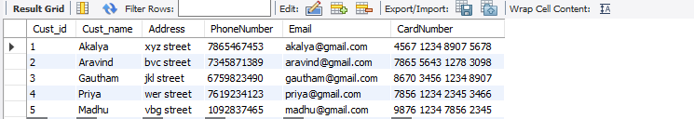

create database project

use project

create table Customer(Cust_id int,Cust_name varchar(200),Address varchar(200),PhoneNumber double,Email varchar(200),CardNumber varchar(200));

insert into Customer values(1,’Akalya’,’xyz street’,7865467453,’akalya@gmail.com’,’4567 1234 8907 5678’);

insert into Customer values(2,’Aravind’,’bvc street’,7345871389,’aravind@gmail.com’,’7865 5643 1278 3098’);

insert into Customer values(3,’Gautham’,’jkl street’,6759823490,’gautham@gmail.com’,’8670 3456 1234 8907’);

insert into Customer values(4,’Priya’,’wer street’,7619234123,’priya@gmail.com’,’7856 1234 2345 3466’);

insert into Customer values(5,’Madhu’,’vbg street’,1092837465,’madhu@gmail.com’,’9876 1234 7856 2345’);

Alter table Customer add primary key(Cust_id);

**Hotel :**

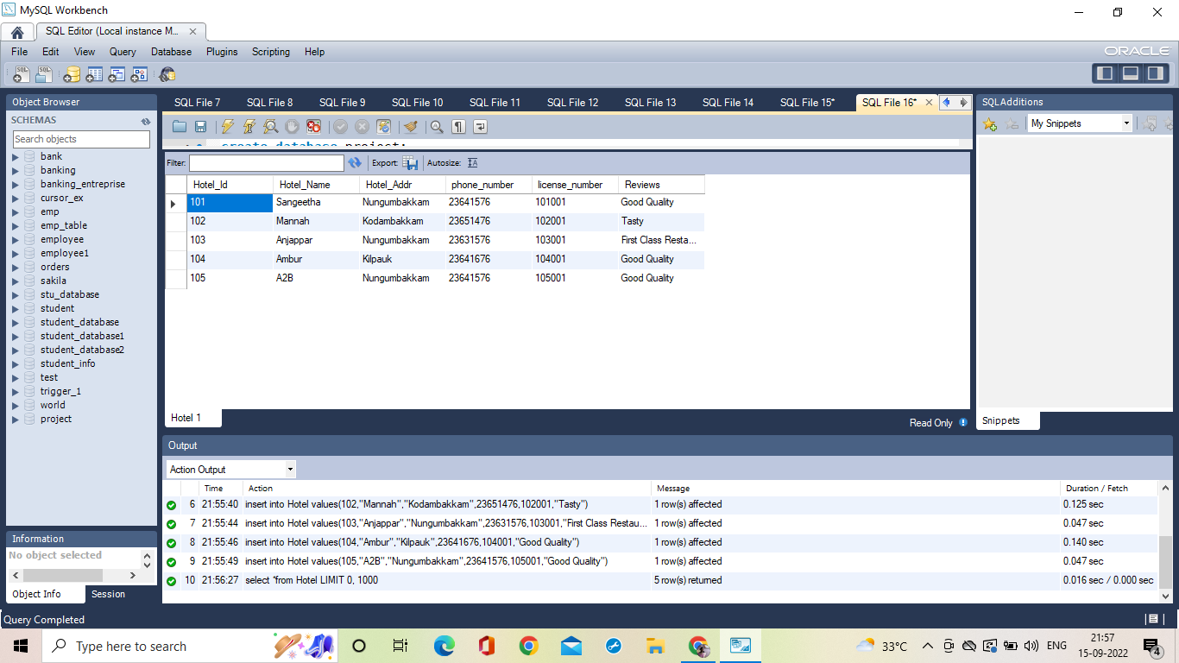

create table Hotel(Hotel_Id int primary key ,Hotel_Name varchar(20),Hotel_Addr varchar(100),phone_number int,license_number int,Reviews varchar(100));

insert into Hotel values(101,’Sangeetha’,’Nungumbakkam’,23641576,101001,’Good Quality’);

insert into Hotel values(102,’Mannah’,’Kodambakkam’,23651476,102001,’Tasty’);

insert into Hotel values(103,’Anjappar’,’Nungambakkam’,23631576,103001,’First Class Restaurant’);

insert into Hotel values(104,’Ambur’,’Kilpauk’,23641676,104001,’Good Quality’);

insert into Hotel values(105,’A2B’,’Nungumbakkam’,23641576,105001,’Good Quality’);

**Food:**

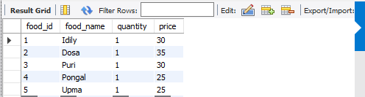

create table Food(food_id int primary key,food_name varchar(20),quantity int, price int)

insert into Food values(001,'Idly',1,30);

insert into Food values(002,'Dosa',1,35);

insert into Food values(003,'Puri',1,30);

insert into Food values(004,'Pongal',1,25);

insert into Food values(005,'Upma',1,25);

**Food Order:**

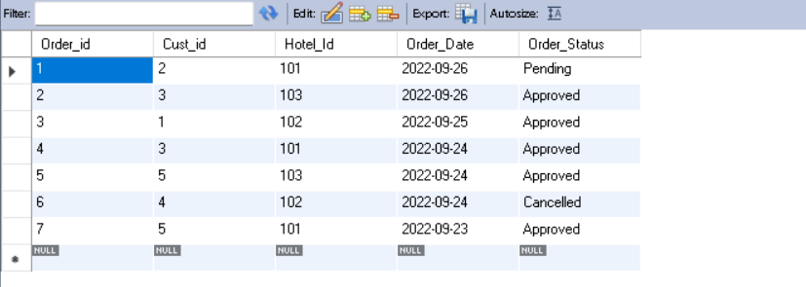

create table FoodOrder (Order_id int primary key, Cust_id int,foreign key(Cust_id) references Customer(Cust_id), Hotel_Id int, foreign key (Hotel_Id) references Hotel(Hotel_Id), Order_Date date, Order_Status varchar(20));

insert into FoodOrder values(1,2,101,'2022-09-26','Pending');

insert into FoodOrder values(2,3,103,'2022-09-26','Approved');

insert into FoodOrder values(3,1,102,'2022-09-25','Approved');

insert into FoodOrder values(4,3,101,'2022-09-24','Approved');

insert into FoodOrder values(5,5,103,'2022-09-24','Approved');

insert into FoodOrder values(6,4,102,'2022-09-24','Canceled');

insert into FoodOrder values(7,5,101,'2022-09-23','Approved');

**Delivery:**

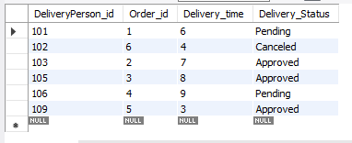

create table Delivery (DeliveryPerson_id int primary key, Order_id int,foreign key(Order_id) references FoodOrder(Order_id), Delivery_time int, Delivery_Status varchar(20));

insert into Delivery values(101,1,6-00,'Pending');

insert into Delivery values(103,2,7-00,'Approved');

insert into Delivery values(105,3,8-00,'Approved');

insert into Delivery values(106,4,9-00,'Pending');

insert into Delivery values(109,5,3-00,'Approved');

insert into Delivery values(102,6,4-00,'Canceled');

insert into Delivery values(108,8,10-00,'Approved');

select* from Delivery;

**Price:**

create table Payment(Mode_of_Payment varchar(100),Order_id int,Coupon_discount int,Total_amount int, Transanction_id int Primary Key,payment_status varchar(100));

insert into Payment values(credit card,100,150,370,01238792178,paid);

insert into Payment values(debit card,789,0,800,7697645435664537,pending)

insert into Payment values(gpay,67,87,860,786523489659875,paid)

insert into Payment values(gpay,428,180,500,733287534387,processing)